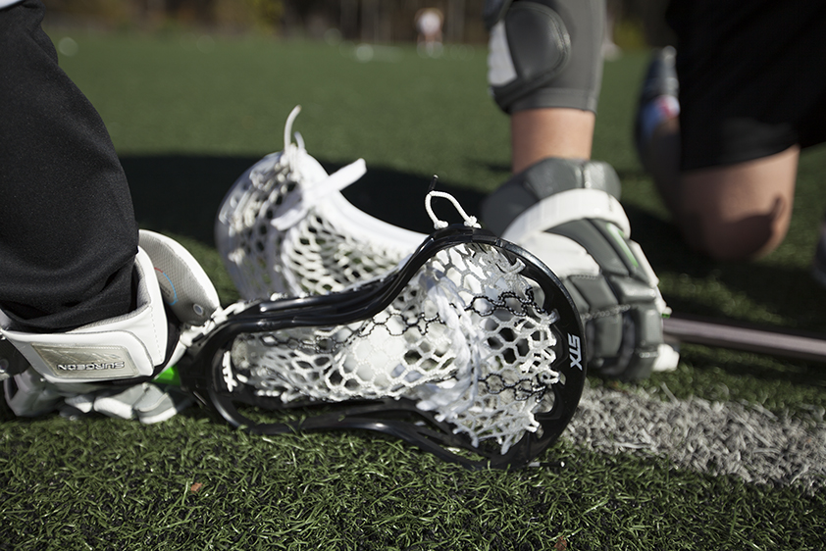
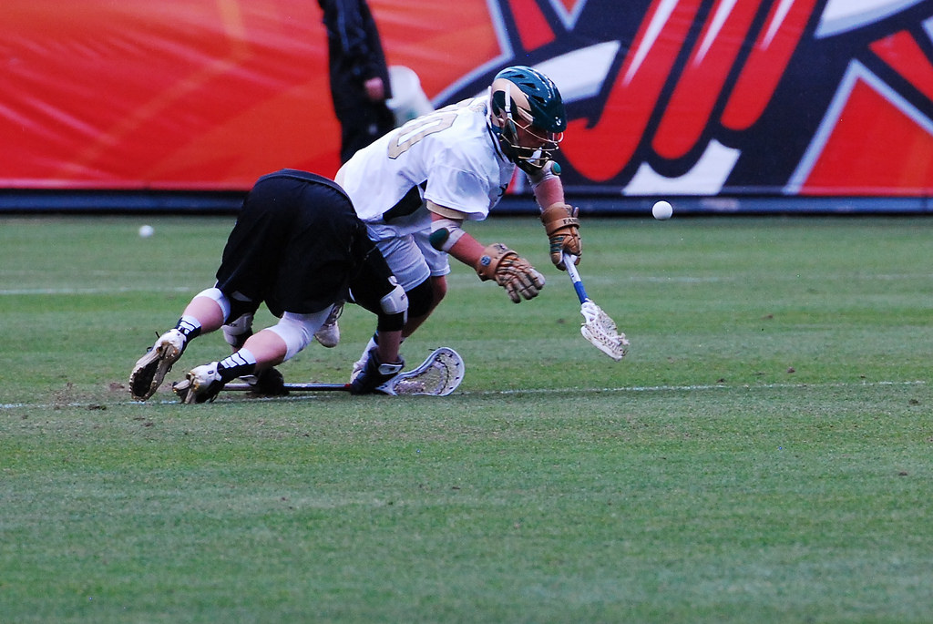
Face-off Clinic

  - Come build your face-off foundation and improve your skills with two time MCLA National Champion and All-American face-off specialist Brian Roach!
Coach Brian Roach will be teaching players the fundamentals of a face-off, while improving quickness, strength, and face-off IQ.
Clinic sessions will cover:
- How to take a face-off, rules of the face-off, and its importance in a game
- Emphasis on proper form and technique
- How to command your wing players
- Adjusting your face-off strategy based off opponent or game situations
Date and Time: Dec. 27, 28, 29 1:00-2:00 PM
Ages: 2nd grade to high school of all skill levels
Cost: $50
Location: Parisi Speed School of Colorado, 4950 S Kipling Pkwy Littleton, CO, 80127
Contact: Brian Roach
Email: Coach.roach@Parisicolorado.com
Phone: (303) 641-4292

